NEW Publications SUBMISSION FORM

Title of Publication | Making policies and by-laws for natural resource management work: Experiences from the highlands of eastern Africa.  In: Kalinganire, A., Yatich, T., Tchoundjeu, Traoré, F., Alinon, K. Weber, J., Roy-Macauley, H., Molnar. A., Bandiaky, S. and Diallo, R. (Eds.) Proceedings of Sahelian Regional workshop “Moving beyond Forestry laws” through collective learning and action. May 04 – 08, 2009, Hotel Azalaï Nord-Sud, Bamako, Mali. 291 – 309.
Author(s) of Publication | Jeremias G. Mowo, Charles Lyamchai, Frank Place, Kenneth Masuki, Zenebe Admasu, Awadh Chemangei,
Name(s) &/or affiliations of Developing Country Partner(s)  (List names of authors from collaborating national institutions and/or national institutions involved) | Charles Lyamchai – Tanzania  Zenebe Admasu – Ethiopia  Awadh Chemangei - Uganda
GRP(s)  (List the GRP(s) under which the work reported here falls) | 2 and 6
Region  (Which ICRAF region does the work cover?) | Eastern Africa
What was known  ( A short statement - on what was known before this work was done) | Inappropriate policies and ineffective natural resources management (NRM) by-laws are a major setback in achieving sustainable natural resource management in the highlands of eastern Africa. This has led to declining agro-ecosystem productivity, food security and rural incomes.
What is new  (A short statement on the new findings reported in the publication ) | It is shown that that lack of pro-poor NRM policies, inadequate participation of farmers and civil society organizations in by-laws formulation and enforcement, poor coordination between different sectors at district level, limited awareness on the part of the local communities on processes of by-laws enforcement and outdated by-laws are some of the major reasons for poor status of agro-based natural resources in the Highlands of eastern Africa.
Target Audience  ( Who is the target audience) | Policy Makers, Extension workers and Researchers
Externally Peer-reviewed?  (Yes or No) | Yes as a paper in conference proceedings
External Peer-review Process  (Briefly describe the process) | After presentation in the Conference in Bamako the paper was reviewed before being published in the proceedings.
Formally published in full text? (Yes or No; if yes, give page range in source document) | Yes, 291 - 309

Session IV: Formulation and integration of by-laws

Making policies and by-laws for natural resource management work: Experiences from the highlands of eastern Africa

Jeremias G. Mowo², Charles Lyamchai³, Frank Place², Kenneth Masuki⁴, Zenebe Admasu⁵, Awadh Chemangei⁶,

²World Agroforestry centre (ICRAF), Box 30677 – 00100, Nairobi, Kenya
³Selian Agricultural Research Institute, Box 6024, Arusha, Tanzania
⁴World Agroforestry Centre, Box 26416, Kampala, Uganda
⁵Ethiopian Institute of Agricultural Research (EIAR), Box 2003, Addis Ababa, ⁶Kapchorwa District Landcare Chapter, Box 2 Kapchorwa, Uganda

Corresponding author: j.mowo@cgiar.org

Abstract

Inappropriate policies and ineffective natural resources management by-laws are a major setback in achieving sustainable natural resource management (NRM) in the highlands of eastern Africa. This has led to declining agro-ecosystem productivity, food security and rural incomes as well as increasing health hazards resulting from deteriorating environmental health. In this paper the community participation in the process of bylaws formulation, implementation and enforcement of agro-based natural resources by-laws were studied in three eastern African countries (Uganda, Tanzania and Ethiopia) to establish major reasons for their ineffectiveness and identify opportunities that can reverse this trend The study is based on the hypothesis that successful NRM is strongly dependent on the presence of active by-laws at the community level and strong support of relevant district level institutions of governance to local level institutions in their enforcement. Secondary data, case studies, key informants interviews and series of workshops involving different stakeholders were conducted to understand the relevant NRM policies and the process of by-laws formulation and factors affecting their implementation and enforcement. Results shows that lack of pro-poor NRM policies, inadequate participation of farmers and civil society organizations in by-laws formulation and enforcement, poor coordination between different sectors at district level, limited awareness on the part of the local communities on processes of by-laws enforcement and outdated by-laws are some of the major reasons for poor NRM in the eastern African Highlands. Where awareness on the processes of by law enforcement was raised and collaboration between policy makers and law enforcers enhanced, cases of abuse of natural resources went down by 67 %. The paper proposes some strategies for enhancing the effectiveness of NRM by-laws in the region for improved and sustainable agro-ecosystem productivity and livelihoods.

Keywords: By-laws enforcement, Eastern Africa highlands, NRM policies & by-laws, Stakeholders’ participation

Introduction

The highlands of Eastern Africa are an important ecosystem economically, socially, politically and in the conservation of biodiversity. These highlands occupy 23 % of the regional landmass, houses over 50 per cent of the region’s population, produce over 50% of the staple foods and most cash crops in the region, and are home to different plants and animals, several of which are endemic to the area. Population densities are high ranging from 100 – 600 people/km² and increasing fast. Agriculture is the major preoccupation of the population with 70 – 80 % involved in farming. An inheritance system characterised by land sub-division to small parcels has led to very small land available per person; ranging from 0.07–0.23ha (Stroud and Peden, 2005).

Degradation of natural resources notably vegetation, land and water in the highlands of eastern Africa is on the increase despite concerted efforts by both research and development partners to reverse the trend (Farrington, 1998; Mansuri and Rao, 2004; Mmbaga et al., 2007). Where success has been reported this is mainly confined to small ‘islands’ which have rarely been translated into government-level policy or practice (Okoba, 2005; Carter and Currie-Alder, 2006). The result is declining agro-ecosystem productivity and environmental health as evidenced by declining food security and rural incomes, and increasing health hazards related to environmental pollution. With increasing mouths to feed, a major crisis is inevitable in the region unless corrective measures are taken now.

Many reasons have been advanced for the poor state of natural resource in the region among them being increasing population pressure, shrinking farm size, and limited investment in sustainable land management. The latter is caused by limited adoption of technologies arising from among others; inadequate institutional support as manifested by poor institutional arrangements and limited involvement of the local communities in NRM policy reforms and by-laws formulation and enforcement (Sanginga et al., 2004), weak farmer organizations and lack of support to these organisations by higher levels of governance. Limitations in NRM policy and poor formulation and enforcement of NRM related by-laws stand out prominently as among the majors factor for the increasing trends in natural resource degradation in the highlands of eastern Africa (Stroud and Khendawal, 2006; Lyamchai et al., 2007; Yatich et al., 2007; Mmbaga et al., 2007).

During recent decades, many developing countries have embarked on decentralisation reforms in relation to natural resource management (Agrawal, 2001). In most countries, decentralisation has taken the shape of de-concentration in which the management of natural resources has been handed over to local administrative branches of central government (Ribot 2004; Miller 2004). The government of Uganda decentralized its central executive powers in 1992 to address the lack of involvement of local communities in decision making on local issues such as managing natural resources. Although these efforts have shown promising improvement in the participation of local people and other stakeholders in the policy decision-making process (Saito, 2003), there is concern that decentralisation has not resulted in improvement in the management and use of natural resources. Further, the capacities and decision-making processes of local communities over the management of natural resources have not changed significantly. According to Sanginga et al. (2004) important factor limiting effective NRM in Uganda is the poor implementation and enforcement of relevant by-laws. This is attributed to limited local community involvement in by-laws formulation and enforcement processes. However, it was also noted that the most of the local political leaders and policy makers were not even aware of the existing by-laws and NRM policies and actually they were among those who do not practice conservation (Johnson, 2003).

Tanzania also embarked on devolution of powers in combination with other strategies for effective natural resource management. For instance, the Forest Policy of 1998 (URT, 1998) and Forest Act of 2002 (URT, 2002) provide room for community participation in forest management. The Village Act No. 7 of 1982 revised in 1999 empowers village governments to make by-laws (URT, 1999) although this does not include participation in disputes resolution which is vested in conventional institutions namely the primary court, the district court and the high court. The majority of the people have lost confidence with this machinery for settling disputes because it is bureaucratic, inefficient, away from many people and therefore expensive (Nzioki, 2006). The formulation and implementation of by-laws in Tanzania is plagued with a number of problems. First, the by-laws' formulation process is slow and inefficient. The long and circuitous route for by-laws to be passed and enacted into law by the responsible minister does not allow for effective rule-making. Many natural resource management problems require immediate action, but this is difficult to achieve under the current local government structure (Mniwasa and Shauri, 2001). Most NRM by-laws operating in Tanzania are no longer appropriate given the prevailing socio-economic conditions. For example, Sheridan (2009) reports that in the 1980s and 1990s, those found guilty of cutting a tree in a sacred grove paid a fine of Tsh 1,000/=. This was a heavy penalty (about US$100) when the district’s Protected Areas By-laws were passed in 1984, but today it is worth only about US$0.75. Further, there is absence of realistic strategies for implementing some of the NRM by-laws.

Weak enforcement of existing by-laws was also found to contribute to the failure of invested conservation efforts in Tanzania (Sheridan, 2009). Apart from the fact that law enforcers are not enough, there is widespread corruption and resentment by the local communities (especially local leaders) who feel excluded in the process of by-laws enforcement. The conventional system of law enforcement overlooked the local machinery that existed in the past and which was rooted in the local culture. For effective enforcement of NRM by-laws close partnership with customary institutions is vital (Nkonya, 2006). These institutions were more participatory than statutory institutions, and local communities were able to enact and enforce their own laws (Nkonya et al. (2005). Colding and Folke (2000) argue that informal institutions may facilitate a reduction of transaction costs by providing for reduced costs in institutional monitoring, enforcement of appropriators, and sanctioning of violators. Conventional law enforcement system has led to serious disputes between relatives in the communities especially when punishment involves imprisonment. No wonder, most community leaders shy away from reporting violators to avoid compromising social relations and for their security.

In Ethiopia, efforts to build an administratively centralized state as a reaction to European colonialism in other parts of Africa systematically destroyed local community governance because it was suspected that such communities could become possible allies of colonialists. Loss of local governance undermined local natural resource management with loss of protection of woody vegetation, lack of repair of old terraces, and general undermining of any attempts at communal management of natural resources (Edwards et al., 2007). A study by German et al. (2008) found that one of the problems of NRM in Ethiopia is poor natural resource governance, including poor negotiation capacity and weak by-laws. Indigenous laws and customs in Ethiopia have traditionally governed access to natural resources and resolved conflicts over resources. However, these indigenous systems are coming under threat from the enforcement of new laws regarding access to and ownership of natural resources (Edossa et al., 2005).

It is clear from the different experiences narrated above that, while national policies on natural resources management are widespread; they are often poorly implemented due to ineffective enforcement mechanisms. Despite limited enforcement of national policies, local people do value the need for rules and regulations on land management and suffer from the consequences of poor governance.

Generally, by-law negotiations are lively events that easily sustain the interest of participants. Local residents can easily identify issues requiring improved governance as well as appropriate policy specifications, illustrating the importance of natural resource governance to local livelihoods and environmental sustainability. As noted by Alinon and Kalinganire (2008) by-laws are important for resource management as they constitute an arena of power negotiation between decentralized bodies and traditional institutions.

In this study it is hypothesized that successful natural resource management is strongly dependent on the presence of active by-laws at the community level and strong support of traditional system in their enforcement. The objective of the study was therefore to understand the factors influencing implementation and enforcement of by-laws and available strategies for ensuring appropriate NRM polices and active by-laws for sustainable land management in the highlands of eastern Africa. The study was guided by the following research questions; (i) what are the available by-laws that govern natural resources management and use? (ii) what are the factors responsible for the limited effectiveness of existing NRM by-laws? and (iii) what are the available opportunities for ensuring effective NRM policies and active by-laws for sustainable land management?

Methodology

Characteristics of study areas

The research was conducted in five benchmark sites of the African Highlands Initiative (AHI), a program operating in 10 east and central African countries (Figure 1). AHI was formerly a network of the Association for Strengthening Agricultural Research in East and Central Africa (ASARECA) and an Eco-regional programme of the Consultative Group for International Agricultural Research (CGIAR) hosted by the World Agroforestry Centre (ICRAF). Currently, it is under the Eastern Africa Programme of ICRAF. Characteristically, AHI benchmark sites are district sized and were selected to meet the criteria of high altitude (>1400 m.a.sl.), adequate rainfall (>1,000mm per year) high population density (>100 people/km²) and showing signs of stress such as declining crop and livestock production, excessive fragmentation of land holdings, increasing rural poverty and limited cash opportunities. The five sites are Lushoto in north eastern Tanzania, Areka and Ginchi in southern and northern Ethiopia respectively and Kabale and Kapchorwa in south western and eastern Uganda respectively. Table 1 shows the main characteristics of the study sites.

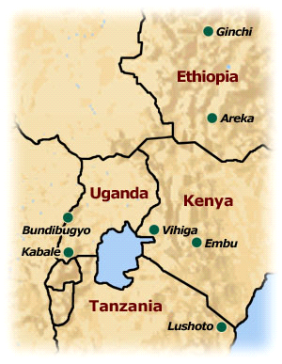
Lushoto, Tanzania
Kabale, Uganda
Kapchorwa, Uganda
Ginchi, Ethiopia
Areka, Ethiopia

Figure 1: The location of the study sites

Table 1: Main characteristics of the study sites

Study sites  (Districts) | Altitude  (m.a.s.l.) | Rainfall  ( mm) | Population density  (people/km²) | Major enterprises
Areka (Ethiopia) | 1800-2600 | 1330 | > 400 | Enset, wheat, pea, maize, barley, faba bean horticulture, communal grazing
Ginchi (Ethiopia) | >2200 |  | 100-200 | Barley, pulses, irish potatoes, wheat, and oilseeds
Kabale (Uganda) | 1500- 2700 | 800-1200 | 100 - 300 | Irish potatoes, beans, field peas, sweet potatoes, bananas, fruit trees, horticultural crops and zero grazing
Kapchorwa (Uganda) | 1000 – 2000 | 1500 | 111 | Millet, Irish potatoes, beans, Simsim, sunflower, , coffee, wheat, maize, beans, banana, barley, and horticultural crops
Lushoto (Tanzania) | 1100-1450 | 800-1700 | 200-300 | Maize, banana, tea, coffee, horticulture in valley bottoms, high-value trees, zero grazing

Study Approach

The study used literature review, case studies, participatory methods and workshops in understanding the dynamics of NRM policy and by-laws reforms, implementation and enforcement in the study sites. The study disaggregated farmers into different categories including gender, resource endowment and age to get the views of the different groups since policies and by-laws will affect each group differently.

Review of existing by-laws
A review of existing by-laws was done through searching various literature including district and village reports to identify the by-laws related to natural resource management and use.

Participatory approaches:
Case studies, key informers interviews and focus group discussions were used in the different sites to understand how policy and by-law reforms are conducted, factors impeding by-laws implementation and available strategies to make by-laws work for the benefit of the communities and for sustainable land management.
In Kabale pilot participatory policy learning and action research approach aimed at strengthening local-level processes and capacity for developing, implementing and enforcing local policies and by-laws to improve natural resource management In Tanzania, a survey was conducted using key informants with a check-list to identify ineffective NRM policies and by-laws and to derive strategies for participatory reforms, implementation and enforcement. In Ethiopia, sensitization combined with persuasion and persistent meetings to promote dialogue on issues once considered intractable were the strategies used to reach consensus and come up with by-laws agreeable by all. Local committees were appointed to lead the process of by-laws formulation and reforms that helped mobilizing collective action around agreed resolutions.

Stakeholders’ workshops:
This was followed by a series of meetings with different stakeholder groups to share experiences in INRM approaches for Lushoto District. During these meetings, more information was collected pertaining to by-law formulation, enactment and implementation and problems encountered in their enforcement. A series of stakeholders workshops were conducted during the course of this study. In Tanzania, the first workshop involved different government institutions within Lushoto district, non-governmental organizations (NGOs), farmer representatives and division executive officers from study site. Deliberations made during this workshop led to the second workshop which in addition to the members for the first workshop, the police and judiciary departments were invited. In Uganda and Ethiopia site-level workshops on the feedback of findings and identification of NRM issues requiring collective action, changes in institutional practice and / or by-law reforms were conducted.

Results and discussion

Flaws in the existing NRM related policies and by-laws

Critical review of existing NRM policies and by-laws revealed several flaws which explain their ineffectiveness in arresting natural resource degradation in the highlands of eastern Africa. These can be considered under three areas namely; (i) relevance of some of the NRM policies and by-laws, (ii) inadequacy of NRM policies and by-laws in ensuring effective NRM and use, and (iii) proposed penalties for violators.

Relevance of NRM policies and by-laws: Several of the policies and by-laws on NRM found in the study areas were outdated and do not reflect the real situation on the ground. A good example on relevance of NRM policies and by-laws was observed in Lushoto, Tanzania. The by-law on protection of water sources, river banks and gullies in Lushoto prohibits the cultivation, cutting of trees or grass or grazing within 15 meters from a river bank, gully or a spring. In practice no one including the community leaders observes this law given the very small pieces of land households own. Fifteen meters from a river bank represent too large an area compared to the average land sizes in the highly populated highlands. Although we are not advocating that farmers should cultivate up to the edges of the water sources (Figure 2) tsuch by-laws should be reviewed to take into consideration the reality on the ground and the available technologies which could complement such reforms for protecting water sources while ensuring that communities are not deprived of livelihood.
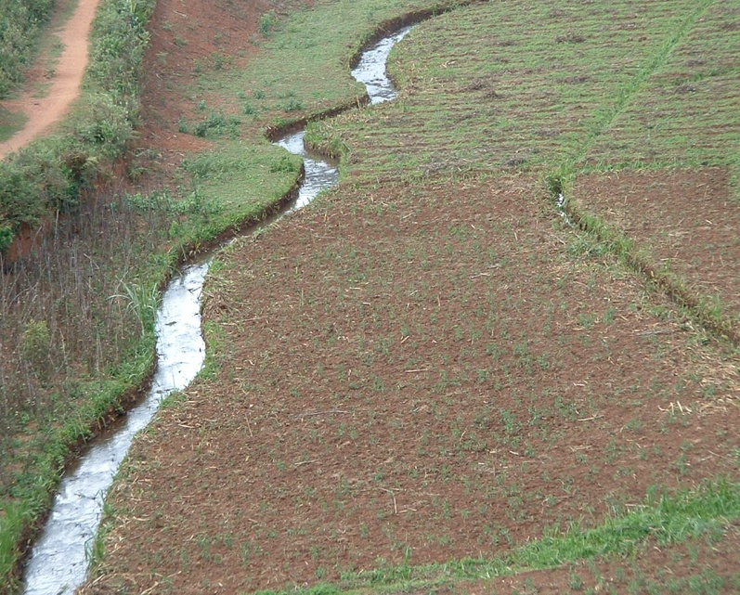
In Ginchi, Ethiopia, policies on soil conservation formulated in the seventies aimed at controlling soil losses, and maintain and improve soil fertility using physical structures, such as soil and stone bunds, and terraces. With no participation of the farmers in their formulation the policies and related by-laws failed to take into consideration the land preparation practices of the farmers (Tesfaye et al., 2006). As a result the policy was not favourably accepted by most of the farmers and it led to the destruction of established physical structures in the latter years.
Figure 2: Cultivation up to edges of water sources is common in the highlands of eastern Africa

Inadequacy of NRM policies and by-laws: Most by-laws are too general and not detailed enough to guide enforcers of the laws effectively. The highlands of Eastern Africa are characterized by very steep slopes with farmers cultivating areas with slopes greater than 50 % without any soil conservation measures. In most cases, few farmers adopt any such measures; mostly those directly involved in soil and water management projects. This has led to patchy rather than continuous landscape level conservation with dire consequences for farmers who have conserved. This is a potentially explosive situation because runoff from non-conserved plots has the potential to destroy neighboring conserved plots as well as contributing to siltation of the fertile valley bottoms. Yet, in Lushoto for example, the available by-laws do not say anything on what should happen to such destruction from non – conserving farmers. In Kapchorwa, eastern Uganda, policy and by-laws for the protection of Mount Elgon National Park by the Uganda Wildlife Authority (UWA) failed to recognize the plight of the Benet Communities who are essentially forest dwellers and hence most of them have been disfranchised. These communities relied on the forest resources in the now protected areas and by enacting laws that criminalize them for accessing their source of livelihood without offering alternatives led to a protracted court case which by the time AHI stepped in was still not resolved. The result was poor relations between UWA and the community. The AHI supported an out of court negotiated solution between the two parts which emphasized on each one dropping the contentious conditionalities to allow a win-win solution. Had UWA involved the communities from the beginning the crisis would not have soared to the levels AHI found.

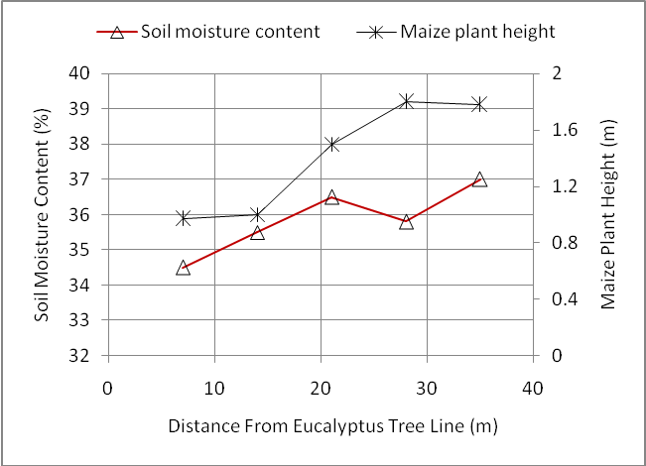
In most of the sites the existing policies and by-laws are silent on the effect of undesirable boundary trees affecting crops of neighbour’s plots (Figure 3). There is a growing concern and conflicts related to such boundary trees in the region. Most Eucalyptus species for example, are known for their higher consumption of water and allelopathic effects on adjacent crops and have been blamed for being responsible for degradation
Figure 3: Effects of Eucalyptus tree line on soil
moisture content and maize plant height
of water sources and soils in the highlands of eastern Africa (Mowo et al 2004; Meliyo et al,. 2004; Laura et al., 2004). Researchers should therefore work closely with policy makers to provide them with the scientific evidence on basis of which appropriate policies and by-laws can be made.

Penalties for offenders: In most cases it was found that the penalties meted out for abuse of natural resources were too weak to discourage would be offenders. Fines currently in force were established a long time ago when the local currencies were stronger and they have not been reviewed upward to reflect the real current value of natural resources. Table 2 shows the current penalties imposed on abusers of natural resources in Kabale, Uganda and Lushoto, Tanzania. Such penalties which include very short jail terms are too weak to discourage violators to shun from repeating the same or similar offences. Similar observations were made by Sheridan (2009) in northern Tanzania where fines imposed on violators were established in the 1980s and 1990s when the Tanzanian shilling (Tsh.) was more than 100 times stronger.

Table 2: Fines imposed on NRM related offences in Lushoto (Tanzania) and
Kabale & Kapchorwa (Uganda)

NRM related by-laws | Penalty
Lushoto - Tanzania | Tanzania Shilling | Equivalent USD
- Uncontrolled grazing of livestock | 5,000 | 3.8
- Starting wild fires without permission | 5,000 | 3.8
- Failure to appear in collective action campaigns | 2,000 | 1.5
- Cultivation near water sources | 10,000 | 7.6
Kabale, Uganda | Uganda Shilling | Equivalent USD
- Failure to protect cattle tracks and other paths from soil erosion (First conviction) | 3,000 (first conviction) | 1.4
 | 5,000 second conviction plus 15 days jail term | 2.3
- Failure to plant 2 trees for each tree cut  - Failure to plant recommended agroforestry trees on farm boundaries and terraces | 3,000 (first conviction) | 1.4
 | 21 days imprisonment and planting the number of trees cut | N.A.
Kapchorwa – eastern Uganda
- Failure to plant trees in your farm  - Failure to plant tree on steep slopes and along the river banks | 10,000 | 4.7
Source: Lushoto, Kabale and Kapchorwa District Councils reports

Problems in implementation and enforcement of by-laws on NRM

Poor implementation and enforcement of by-laws is responsible for the increased degradation of natural resource commonly observed in the highlands in eastern Africa. Several factors were identified that impede effective implementation and enforcement of by-laws. These can be summarized under four headings namely; (i) Limited understanding of laws and by-laws by the community, (ii) limited involvement of communities in formulation and enforcement of by-laws, (iii) poor community leadership and (iv) social relations and politics.

- Limited understanding of laws and by-laws by the community: The study revealed that overall there is little understanding of laws and by-laws by the communities which lead to defaulters not being apprehended and prosecuted. A good example was shown by one village called Kwalei in Lushoto District, Tanzania, where village leaders were discouraged when their fellow farmer continued to destroy the village water source while he was under a six-month suspended sentence for the same offence (Box 1).

- Limited involvement of communities in formulation and enforcement of by-laws: The study revealed that formulation of most of the existing by-laws did not involve local communities and many farmers were not knowledgeable on the implementation / enforcement mechanisms. For example, in Kapchorwa, eastern Uganda it was revealed that inadequate participation of the poor and civil society organizations in the formulation, implementation and evaluation of site and district level policies and programs coupled with lack of pro-poor policies has weakened implementation and enforcement of existing by-laws. In Kabale, south western Uganda, it was observed that local communities were not fully involved in the formulation of by-laws in NRM. These included by-laws on soil and water conservation, food security, tree planting, bush burning, controlled grazing, and swamp reclamation.

Box 1: Limited understanding of by-laws and their enforcement

The farmer in Kwalei having been given suspended sentence he returned to the village and started harassing the village leaders who were responsible for taking him to court. The leadership did not understand this kind of sentence having expected to see the offender jailed in prison. Through a workshop organised by AHI which involved village leaders, the police, the District Attorney and the district courts the village leaders shared their frustration. The magistrate clarified on the kind of sentence the offender was given and the conditions he was supposed to observe. That is, he was to stay in the village and refrain from breaking any law for 6 months failure of which he would be arrested and sentenced to jail term. This procedure was followed and within a week the culprit was sentenced to 1.5 years in prison to the satisfaction of the village leadership and the rest of the community.

In Ginchi and Areka, Ethiopia, it was observed that when local communities initiated their own mechanisms for enforcing by-laws they were always successful in addressing NRM problems confronting them (Tesfaye, et al., 2006). Through sensitization, persuasion and frequent meetings greater numbers of farmers were encouraged to participate in soil and water management activities including identification of appropriate locations for common waterways in the Ginchi site. It was also used in the management of Eucalyptus around springs and farm boundaries, given the polarized interests around the issue. This approach also enabled agreements to be reached on spring management under a win-win arrangement between villagers and the few farmers whose fields have springs. This was necessary because the latter farmers would deny the rest of the villagers’ access to the springs because they destroy their crops. In Areka, farmers managed to control porcupine, a vertebrate pest that was responsible for tremendous crop losses and wasting of farmer’s time spent in guarding their crops at night. This was possible through collective action enhanced by participatory by-laws formulation and effective enforcement. Success in controlling porcupine resulted to more time being available for NRM activities.

More often, the local leadership is not fully involved in the enforcement of the by-laws and once a case lands in the district court they are rarely consulted. In connection to this is the failure by the conventional system of law enforcement to recognize the role of traditional mechanisms in maintaining law and order. As pointed out by Nkonya (2006) and emphasized by Colding and Folke (2000) such mechanisms were very effective in maintaining law and order in the communities.

- Poor community leadership: Leadership is another very important factor in the enforcement of by-laws. It was found that poor leadership contributed to infectiveness of by-laws because some of the village leaders are not daring enough and would like to be seen as ‘good people’. This way, most offenders are left free leading to more degradation of natural resources. For example, during the study it was observed that in the Ethiopia sites, Development Unit leaders did not fully implement the by-laws and did not open any court cases against offenders in accordance with the formulated by-laws for a long time.

- Social relations and politics: Social relations play very important role in the effectiveness of by-laws enforcement. In most of the sites studied ward and division leaders are from within the same locality where most of the community members reside and they are brothers, sisters, in-laws or long time friends. In such cases preferential treatment is likely to take place depending on the relationship the leader has with the offender.
Conflicting political interests were cited as among the factors impeding effective by-laws enforcement. A very interesting case was that between leaders under government system who are civil servants and political leaders who are elected by communities in the Tanzania site. Leaders elected by the communities would like to retain their seats whereas government appointed leaders do not have such fears. As a result conflicts will always be there between the two groups, further affecting implementation and enforcement of by-laws.

Strategies for making policies and by-laws in NRM work

Through interaction with farmers and different other stakeholders several strategies were proposed to ensure NRM policies and by-laws work in the highlands of eastern Africa. These are; (i) capacity building of communities and their leaders on the existing laws and by-laws, (ii) training of leaders on good governance, (iii)frequent review of NRM by-laws and (iv) full participation of communities in by-laws reforms and enforcement.

Capacity building of communities and their leaders on NRMby-laws Magistrates who attended the Lushoto Policy and By-laws Workshop commented that “It is the obligation of every citizen to know and understand the governing laws including by-laws”. He even encouraged people to be attending different court sessions so as to learn more on laws and by-laws, and the court procedures for their enforcement. Frequent exposure of community leaders as well as farmer groups is an effective strategy of building their capacity to participation in policy and by-law reforms. Similar efforts should be directed to local policy makers and law enforcers who should also be knowledgeable on the importance of safeguarding the natural resources. In Lushoto, for example, the exposure of communities, policy makers and law enforcers to NRM through the different AHI knowledge products led into communities becoming more aware of the need to better manage resources and motivated policy makers and law enforcers to take stern measures against community members who go against established relevant by- laws. As a result, cases of resource abuse which were more numerous prior to AHI intervention went down by 67% (Figure 4).

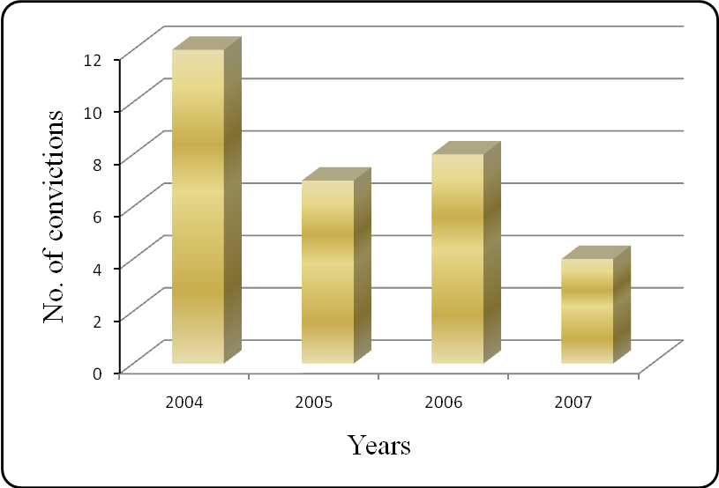

Figure 4: Impact of awareness creation on the number of NRM
related convictions in Lushoto, Tanzania.

Training of leaders on good governance: Training of leaders on good governance was found to be a very important option to deal with the problem of limited leadership skills which lead to weak, corrupt and lack of confidence in enforcing laws and by-laws. This should be addressed through training in good governance including skills on how to ensure equality and equity among the different social groups in the communities. Training on by-law reforms to match with the existing situations was found necessary. This will help in revisiting the penalties, mode of action depending on the reality on ground.

Frequent review of NRM by-laws: Frequent reviews of NRM policies and by-laws will ensure that they are not outdated. Similarly, the penalties associated with the different by-laws should be revisited from time to time to ensure they are deterrent enough. Otherwise, having a long list of by-laws which no one implement and which are difficult to enforce will not ensure sustainable management of the natural resources.

Full participation of communities in by-laws reforms and enforcement: Community involvement should also include recognition of the traditional mechanisms for maintaining law and order. The involvement of local communities in Kabale, Uganda and Ginchi and Areka in Ethiopia in by-laws reform led to successful implementation and enforcement with good results. Due to this in Kabale some communities constructed more than 600 trenches for controlling soil erosion and water run-off; and have initiated community agroforestry nurseries. In Kapchorwa, the farmers in Benet community were able to review the formal and informal existing by-laws and in some case reformulate new ones to reinforce the existing ones. A framework for by-laws reform (Table 3) was established which critically looks at the problem, its cause and effects and the appropriate by-laws and realistic penalties to ensure the degradation of natural resources is controlled. Taking the community through this process will make them understand the relation between actions on their farms and the effects their plots and those of their neighbours so that they appreciate and accept the penalties imposed for their benefit, that of their neighbours and the environment beyond their area.
Table 3: Framework for by-laws reform. Example from Kapchorwa, Eastern Uganda

Problem | Cause | Effect | By-laws |  | Penalties
Problem | Cause | Effect | Existing | Modified | Penalties
- Excess run off  - Soil erosion | - Poor cultivation methods  - Deforestation  - Lack of conservation | - Loss of top soil  - Siltation of valley bottoms  - Floods | - | - On conservation  - Controlling run-off  - On indiscriminate cutting of trees | 2.3 – 20 USD  + Jail term  +  Planting trees

Conclusion

The study shows that the success in natural resource management is strongly dependent on having relevant policies and active by-laws at grassroots level. On the other hand active by-laws are the outcome of strong, skilled and impartial leadership which is not currently present in the study areas thus calling for concerted efforts in capacity building of community leadership training. The involvement of all stakeholders in NRM is of great importance for the effective NRM. Police and the courts often not involved in NRM projects are therefore indispensable partners in ensuring that NRM by-laws are followed and adhered to. Many other recommendations to make NRM policy and by-laws more effective require capacity building of different other stakeholders including policy and decision makers at district and national levels. This requires initiatives to facilitate and promote policy dialogue between the different stakeholders and support policy learning and action. Finally, we should not overlook the traditional mechanisms that were used in the past with so much success in ensuring natural resources are protected for the benefits of the different generations.

References

Agrawal, A. (2001): The decentralizing state: Nature and origins of changing environmental policies in Africa and Latin America 1980–2000. Paper prepared for the 97th Annual Meeting of the American Political Science Association, 30 August – September, San Francisco, California.
Alinon, K., and Kalinganire, A. (2008). Effectiveness of by-laws in the management of natural resources: The West African Experience. CAPRi Working Paper No. 93 December 2008.
Carter, S.E. and Currie-Alder, B. (2006). Scaling-up natural resource management: insights from research in Latin America. Development in Practice 16: 128-140.
Colding, J. and Folke, C. (2000). The taboo system: Lessons about informal institutions for nature management. The Georgetown International Environmental Review XII: 413-445.
Dery, B. B., Otsyina, R. and Ng'atigwa, C. (1999). Indigenous Knowledge of Medicinal Plants and Setting Priorities for their Domestication in Shinyanga Region, Tanzania. ICRAF, Nairobi.
Edossa, D.C., Babel, M.S., Gupta, A.D. and Awulachew, S.B. (2005). Indigenous systems of conflict resolution in Oromia, Ethiopia’, International Workshop on ‘African Water Laws: Plural Legislative Frameworks for Rural Water Management in Africa’, Johannesburg, South Africa.
Edwards, S. (2007). The impact of compost use on crop yields in Tigray, Ethiopia. Institute for Sustainable Development (ISD). Proceedings of the International Conference on Organic Agriculture and Food Security. FAO, Rom. Obtainable at: ftp://ftp.fao.org/paia/organicag/ofs/02-Edwards.pdf.
Farrington, J. (1998). Organizational roles in farmer participatory research and extension: lessons from the last decade. Natural Resources Perspectives 27. Overseas Development Institute, London, UK.
German, L., Sellungato, M., Charamila, S., Shemdoe, R. and Mowo, J.G. 2004 Eucalyptus: Friend or Foe? African Highlands Initiative.
German, L. Mazengia, W. Tirwomwe, W., Ayele, S. Tanui, J., Nyangas, S., Begashaw, L., Taye, H., Admassu, Z., Tsegaye, M., Mekonnen, F.A., Aberra, K., Chemangeni, A., Cheptegei, W., Tolera, T., Jotte, Z., and Bedane, K. (2008). Enabling Equitable Collective Action and Policy Change for Poverty Reduction and Improved Natural Resource Management in the Eastern African Highlands African Highlands Initiative, CAPRi Working Paper 86. Washington, DC: IFPRI. 2008.
Johnson, D. (2003). Research on Collective Action and Grassroots Innovation in Natural Resource Management: Uganda Case Studies. African Highlands Initiative (AHI) / World Agroforestry Centre, Kampala, Uganda. 64p.
Lyamchai, C.J., Ngatoluwa, R., Mmbaga, T.E. Massawe, N.F., Lema, N., Catacutan, D.C. and Tanui, J. (2007). Policy and Institutional Context for Natural Resource Management in Tanzania: A Basis for Developing a Landcare Program. Working Paper No. 65. ICRAF East Africa
Mansuri, G. and Rao, V. (2004). Community-based and –Driven Development: A critical review. The World Bank Research Observer 19-1.
Meliyo, J.L. Mansoor, A.H., Masuki, K.F.G., Mowo, J.G., German, L. and Shemdoe, R.S. 2004. Social –Economic and Biophysical characterization of Baga Watershed in Lushoto District, Tanzania. African Highlands Initiative (AHI) Lushoto and Ministry of Agriculture and Food Security. Site Report No 1: 2004
Miller, F. (2004). Chapter Four: Forest Management in Cambodia in: Independent Forest Sector Review Cambodia.
Mmbaga, T.E., Lyamchai, C., Mansoor, H. and Wickama, J. (2007). Report on practical approaches for effective by-laws in Lushoto District
Mniwasa, E. and Shauri, V. (2001). Review of the Decentralization Process and it’s impact on Environmental and Natural Resources Management in Tanzania. LEAT, Tanzania.
Mowo, J.G., Wickama, J.M. and Mathias S. 2005. Eucalyptus and water sources in the Usambara Mountains: Farmers’ perceptions. Paper presented at the Sensitization Workshop on Eucalyptus, Dar es Salaam, Tanzania. 17 – 18, February 2005
Nkonya, E., J. Pender, E. Kato, S. Mugarura, and J. Muwonge 2005. Who Knows, Who Cares? Determinants of Enactment, Awareness and Compliance with Community Natural Resource Management. CAPRi Working Paper 41. Washington DC: IFPRI. 2005.
Nkonya, L. K. (2006). Drinking From Own Cistern: Customary Institutions and Their Impacts on Rural Water Management in Tanzania. PhD Thesis, Department of Sociology, Anthropology, and Social Work, College of Arts and Sciences, Kansas State University, Manhattan, Kansas.
Nzioki, A. (2006). Land Policies in sub-Saharan Africa. Centre for Lands, Economy and Rights of Women (CLEAR), Nairobi, Kenya.
Okoba, B.O. and de Graaff, J. 2005. Farmers’ knowledge and perceptions of soil erosion and conservation measures in the central highlands, Kenya. Land Degradation & Development 16: 475-487.
Ribot, J. C. (2004). Waiting for Democracy – The Politics of Choice in Natural Resource Decentralization. WRI Report, World Resources Institute.
Saito, F. (2003). Decentralization and Development Partnerships: Lessons from Uganda Tokyo: Springer.
Sanginga, P.C., Kamugisha, R., Martin, A., Kakuru, A. and Stroud, A. (2004). Facilitating participatory processes for policy change in natural resource management: Lessons from the highlands of south-western Uganda. Journal of Agricultural Sciences, 2004, 9:958-970
Sheridan, M. J. (2009). The Environmental and Social History of African Sacred Groves: A Tanzanian Case Study. African Studies Review, Volume 52, Number 1, pp. 73–98
Stroud A. and Peden D. (2005). Situation analysis for the intensively cultivated highlands of East and Central Africa Part A: 2005; An input into the AHI strategy for ASARECA 2005 – 2010.
Stroud, A. and Khandelwal, R. (2006). In Search of Substance: "State of the Art" of Approaches, Strategies and Methods for Improving Natural Resource Management and Livelihoods. AHI Working Papers No. 6.
Tesfaye, A., Bedane, K., Desalegn, G., Opondo, C and German, L. 2006. Policy issues that affect natural resource management in the watershed areas of Ginchi, Ethiopia. In: Integrated Natural Resources Management in Practice: Enabling communities to improve mountain livelihoods and landscapes. Amede, T., German, L., Opondo, C., Rao, S. and Stroud, A. (eds.), Proceedings of a conference held at ICRAF HQs, Nairobi, Kenya on October 12 – 15, 2004. African Highlands Initiative (AHI), Kampala, Uganda
URT (1998). National Forest Policy. Ministry of Natural Resources and Tourism, Dar es Salaam, March 1998.
URT (1999). The Village Land Act. No. 5 of 1999. Government of Tanzania.
URT (2002). The Forest Act, no. 7 of 7th June 2002, Ministry of Natural Resources and Tourism, The United Republic of Tanzania. Government Printer, Dar es Salaam, Tanzania, 174 pp
Yatich, T., Awiti, A., Nyukuri, E., Mutua, J., Kyalo, A., Tanui, J., and Catacutan. D., (2007). Policy and Institutional Context for NRM in Kenya: Challenges and Opportunities for Landcare. Working Paper No. 43. ICRAF –East Africa.

Proceedings of Sahelian Regional workshop “Moving beyond Forestry laws” through collective learning and action. May 04 – 08, 2009, Hotel Azalaï Nord-Sud, Bamako, Mali. 291 – 309.

